To Do

Add files to grd

Add figures

Add links

# Seasonal

In addition to the spatially defined Typical Assemblages we also derive seasonally distinct assemblages for a subset of river types. The four seasons were defined as follows: spring is March to May, Summer June to August, Fall September to November and Winter December to February.

# Selection of river types

To avoid strong spatial signals in the seasonal typical assemblages (sTA) only those river types were considered in which samples were evenly distributed between seasons. In most cases, an even spatio-temporal distribution could only be achieved by omitting parts of the data (e.g. certain seasons or data sets). The maps for all stream types with all available seasons as well as the respective subsets that were used in the further analyses can be found in the GetRealDrive. An example for Invertebrates in RTXX is shown in figure X1

To visualize difference between the seasons we used Non metric multidimensional scaling (NMDS) on Jaccard dissimilarity matrices. The resulting plots are also available in the GetRealDrive. Figure X2 shows the NMDS plot for invertebrate samples in RTXX. Further, we evaluated whether the Jaccard distance between sites would be better explained by spatial distance or by season. To this end, we employed generalized dissimilarity modelling (GDM).

In GDMs, the response variable is the ecological distance between two sites (expressed in some a priori chosen dissimilarity metric, here Jaccard). Smooth functions are fitted to the environmental data and the differences between the values of these functions at the two sites of interest are used as explanatory variables. By using a generalized modelling framework we can account for the bounded nature of dissimilarity metrics [0-1] and the smooth functions allow for variation in the rate of compositional turnover along gradients. The results for all GDMs can be found in the GetRealDrive, and that for RTXX is shown in figure X3.

Based on NMDS and GDM, we selected RT X and y for Invertebrates and y and x for diatoms. For these four river types sTA were derived in the same way as the non-seasonal TAs (see prior documents in GetRealDrive).

# Pattern, overlap differences

In river type 11, the number of diatom taxa in the sTAs did not vary strongly between the seasons [21 to 28]. The summer and autumn sTAs were more similar to each other than either of them to the winter sTA. The latter was most similar to the summer sTA, as they share some *Gomphonema* species (*Gomphonema olivaceum olivaceoides* and *Gomphonema parvulum* Complex) which are absent from the autumn sTA with exception of the *Gomphonema pumilum* Complex.

|  |  |  |  |
| --- | --- | --- | --- |
|  | Summer | Autumn | Winter |
| Summer (n = 28) | 100 | 46.4 | 35.7 |
| Autumn (n = 21) | 61.9 | 100 | 38.1 |
| Winter (n = 22) | 45.5 | 36.4 | 100 |

The sTAs in river type 15, the winter sTA is considerably larger than the summer and autumn sTAs.

|  |  |  |  |
| --- | --- | --- | --- |
|  | Summer | Autumn | Winter |
| Summer (n = 19) | 100 | 57.9 | 81.2 |
| Autumn (n = 16) | 68.8 | 100 | 81.2 |
| Winter (n = 29) | 41.4 | 44.8 | 100 |

The overlap between the summer sTA and the winter sTA is 81.2%. The same holds for the autumn sTA and the winter sTA. Therefore, they cross the threshold of 75% overlap we used to delineate spatially redundant TAs. The overlap between the winter sTA and either summer or autumn sTA is of a similar size (41.4% and 44.8%). In general, the overlaps in river type 15 are larger than those in river type 11 which might indicate a weaker seasonal turnover in these ecosystems.

RT10+11 MZB

For the macroinvertebrates, the number of taxa in the sTAs is lower than for diatoms. In the both river types, the number of taxa in the autumn sTA is also markedly higher than for all other sTAs.

In the combined river type 10 + 11, the spring sTA was nested in the winter sTA and had no overlap with the summer sTA. The summer sTA was most similar to the autumn TA (71.4% overlap) and vice versa (29.4% overlap). Half of the taxa in the winter TA are also part of the autumn TA which is the highest overlap for the winter TA.

|  |  |  |  |  |
| --- | --- | --- | --- | --- |
|  | Spring | Summer | Autumn | Winter |
| Spring (n = 2) | 100 | 0 | 50 | 100 |
| Summer (n = 7) | 0 | 100 | 71.4 | 28.6 |
| Autumn (n = 17) | 5.9 | 29.4 | 100 | 17.6 |
| Winter (n = 6) | 33.3 | 33.3 | 50 | 100 |

RT1516 MZB

In the other combined river type considered here, RT 15 + 16, the summer TA is nested within the spring TA and the winter TA is almost nested within the winter TA. *Limnoidae* is the only taxon that occurs in the winter TA but not the autumn TA. Across this divide the sTAs only share the two taxa which are common to all four: *Baetis* and *Chironomidae.*

|  |  |  |  |  |
| --- | --- | --- | --- | --- |
|  | Spring | Summer | Autumn | Winter |
| Spring (n = 4) | 100 | 75 | 50 | 50 |
| Summer (n = 3) | 100 | 100 | 66.7 | 66.7 |
| Autumn (n = 16) | 12.5 | 12.5 | 100 | 18.8 |
| Winter (n = 4) | 50 | 50 | 75 | 100 |

Several possible mechanisms that could explain the higher richness in diatom sTAs compared to macroinvertebrate sTAs as well as the higher richness in autumn sTA observed for invertebrates are explored below. Given the way we defined sTAs, a taxon is more likely to become part of a sTA if the total number of samples for that season was lower than for the other seasons. The same hold across taxa, if the number of sampled diatom communities was smaller than that of macroinvertebrates, one might expect more taxa in the sTA.

The number of sampled communities does not differ strongly between taxa (Table 1). Most importantly, the number of macroinvertebrate samples for one river type is lower than that of diatom samples in RT11 and RT15. Thus, the overall difference in richness can not be explained by the number of sampled communities. The mean number of taxa in diatom communities was lower than in macroinvertebrate communities. The total number of taxa was also lower for diatoms than for invertebrates. This might partly also be due to the extensive harmonization efforts that summarized some diatom species in larger complexes. However, it also highlights that there is less variation between sites in river types we considered which is conductive to larger TA. Strong turnover between sites within one stream type or season leads to low average fidelity (B value) and consequently to few taxa that are included in the typical assemblages.

The methodology we employed is an implicit test of the plausibility of the river typology. If the communities would vary completely independently of the typology, there would be not typical assemblages in the field and our method would return small or even empty TAs.

Table : lalala

|  |  |  |  |  |  |  |  |
| --- | --- | --- | --- | --- | --- | --- | --- |
| Class | River Type | Number of sites | Mean Richness | Medium Richness | Standard deviation | Total number of taxa | Samples per season |
| Macroinvertebrate | RT10 + 11 | 385 | 32.7 | 32.0 | 11.7 | 257 | 55/188/103/39 |
| Macroinvertebrate | RT 15 + 16 | 112 | 22.9 | 23.0 | 9.3 | 113 | 7/42/27/36 |
| Diatom | RT 11 | 265 | 23.3 | 22.5 | 7.1 | 140 | 0/157/52/13 |
| Diatom | RT 15 | 230 | 17.1 | 16.0 | 6.5 | 99 | 0/82/19/52 |

There is some indication of a weak positive relationship between number of samples and size of the TA. This is the opposite of what we hypothesized. Note however, that a negative or no relationship are also well within the 95% Confidence Interval. Additionally the higher number of taxa in diatom sTAs is well visible in Figure X and is independent of the sample size.

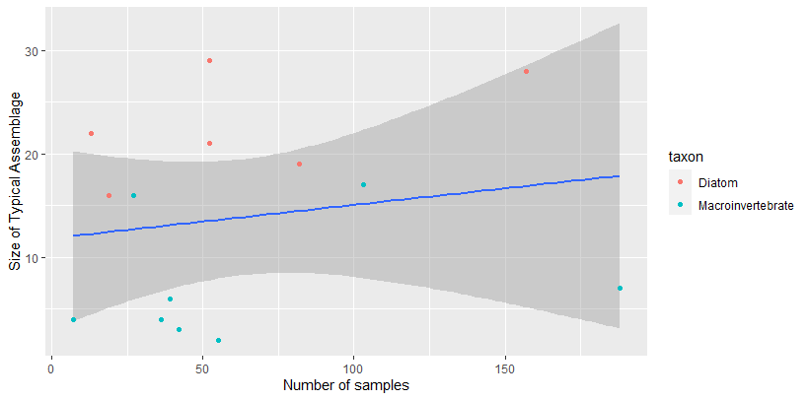

The two following pages show the typical assemblages and their connections.

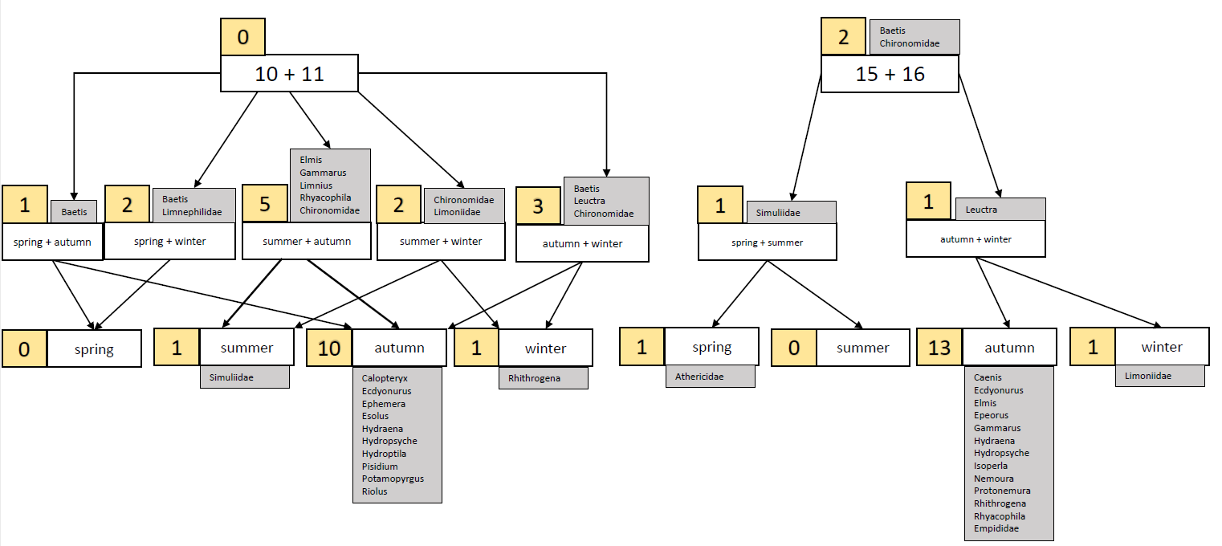

Figure : Seasonal typical macroinvertebrate assemblages (sTA). The figure can be read as follows: The sTA for RT10+11 winter consists of all taxa that are present in all RT10+11 sTAs (none), all taxa that are present in spring and winter (Baetis and Limnephilidae), taxa that are present in summer and winter (Chironomidae and Limoniidae), taxa that are present in autumn and winter (Baetis, Leuctra, Chironomidae) and taxa that are only present in winter (Rhithrogena). The numbers in the yellow boxes show the number of taxa that are associated with a knot.